Portal 2

**Version:** 1.0.0

**Status:** In planning phase

**Goal:** To revolutionize labour engagement by connecting skilled workers directly with those seeking assistance, fostering collaboration through a transparent review and bidding system, and empowering the formation of agile project teams.

**Description:** Welcome to AIO Portal 2- the platform built for revolutionizing labor engagement.

* For Customers:
  + **Seamless Task Outsourcing**: Connect effortlessly with skilled laborers for a diverse range of tasks, from small-scale to medium-scale projects.
  + **Transparent Review and Bidding System**: Gain insights into the expertise of laborers through reviews, allowing you to make informed decisions. Bid on tasks, ensuring fair and competitive pricing.
  + **Agile Project Teams**: Collaborate with skilled laborers to form dynamic project teams, enhancing efficiency and expanding the scope of your projects.
* For Labors:
* **Direct Connection with Clients**: Establish direct connections with individuals seeking your skills, eliminating intermediaries and ensuring a personalized engagement experience.
* **Review and Showcase Skills**: Showcase your skills through a transparent review system, building credibility and attracting more opportunities.
* **Collaboration Opportunities**: Form collaborative teams with other skilled laborers, creating synergies and increasing the potential for larger and more complex projects.

**Tools used :-**

1. **Google Trans python library**
2. **This Portal is under Development ( So still it would be continued to add tools used .)**

**Snapshots of Features :-**

1. Description translation and converting into speech :-

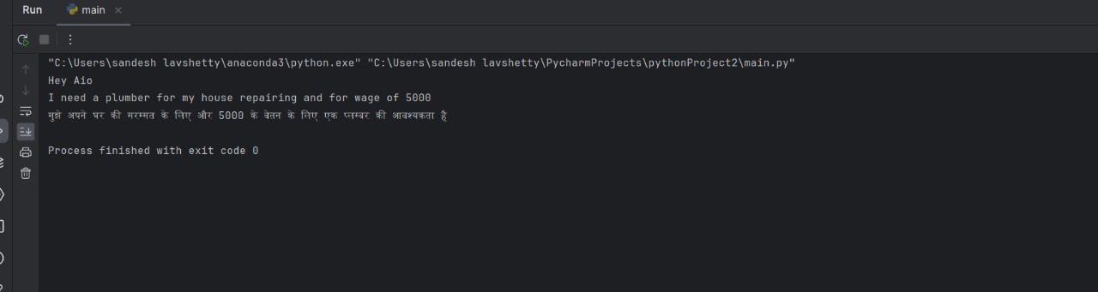

1. **User roles Landing page** :-

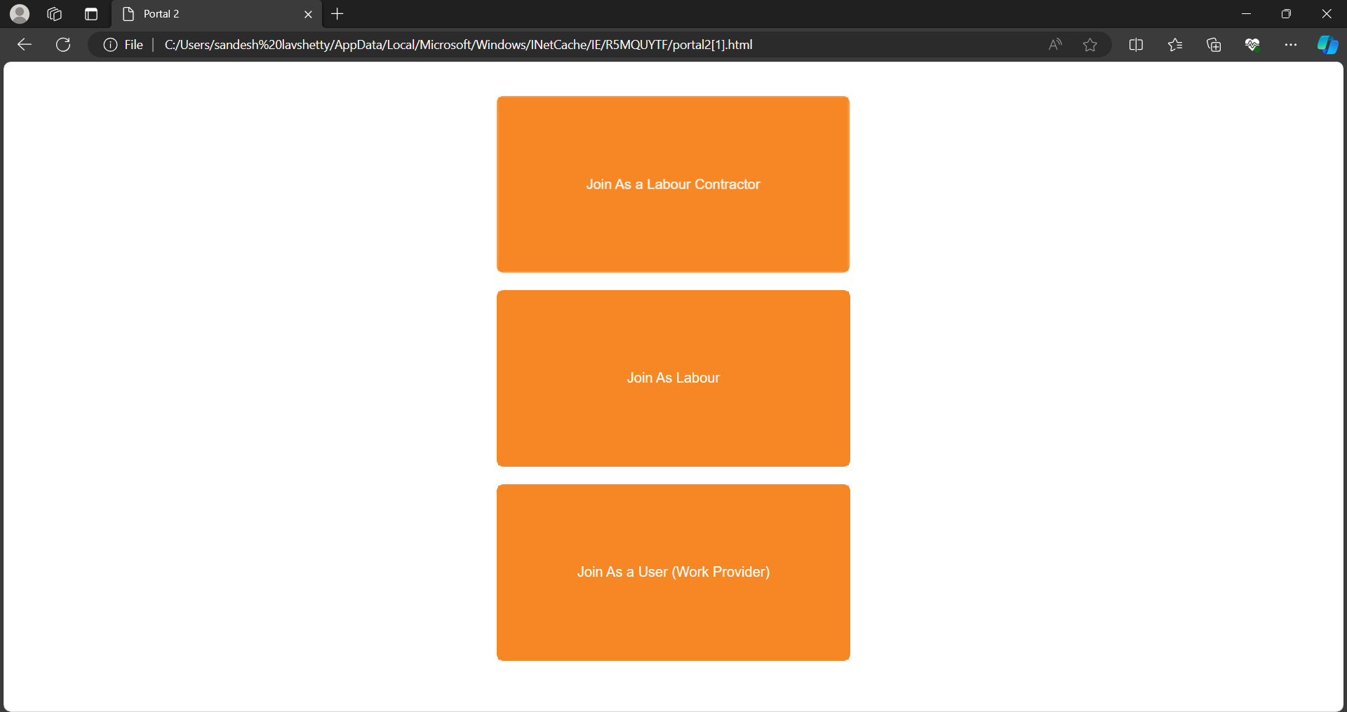

1. **This Portal is under Development**